EXPERIMENT 1 – Arithmetic Operators Using 8085
1. Aim
To develop, execute and verify 8085 assembly language programs for 8-bit and 16-bit addition and subtraction, and for 8-bit and 16-bit multiplication and division, while analyzing carry, borrow and flag-register conditions.
2. Objectives
- To perform 8-bit and 16-bit addition and subtraction using assembly language.
- To implement multiplication using repeated addition and division using repeated subtraction.
- To identify carry and borrow conditions and analyze the processor flags.
- To store the results in specified memory locations.
- To verify the outputs through manual hexadecimal calculations.
3. Expected outcomes
After completing this experiment, students will be able to:
- Write and execute arithmetic programs using the 8085 instruction set.
- Calculate sums, differences, products, quotients and remainders.
- Interpret the carry, borrow, sign, zero, auxiliary-carry and parity flags.
- Use registers and memory addressing modes correctly.
- Compare theoretical and practical results.

4. Software and hardware required
- Intel 8085 microprocessor simulator
- 8085 microprocessor trainer kit
- Keyboard
- Power cord
5. Theory
The 8085 is an 8-bit microprocessor that performs arithmetic operations using its accumulator and general-purpose registers. It can process 8-bit values directly and 16-bit values using register pairs such as HL and DE.
- Addition: The ADD instruction adds two 8-bit values. The DAD instruction adds a register pair to HL.
- Subtraction: The SUB instruction subtracts an 8-bit value. SBB subtracts a value along with the previous borrow.
- Multiplication: Since 8085 has no direct multiplication instruction, repeated addition is used.
- Division: Since 8085 has no direct division instruction, repeated subtraction is used.
- Carry: Indicates a carry out of the most significant bit during addition.
- Borrow: Indicates that the minuend is smaller than the subtrahend in unsigned subtraction.
- Algorithm and procedure
The specific algorithm for each program is given below. The general procedure is:
- Open the 8085 simulator or switch on the trainer kit.
- Enter the assembly program at its specified starting address.
- Load the input data into the specified memory locations.
- Execute the program using the GO/EXEC command.
- Examine the output memory locations.
- Compare the observed results with the theoretical calculations.
- Record the results and verify that there is no deviation.

PROGRAM A – 8 bit addition and subtraction
Algorithm
- Initialize the stack pointer.
- Load the two 8-bit operands from memory into registers.
- Add the operands and save the sum and flags.
- Store the carry separately.
- Subtract the second operand from the first.
- Store the difference, borrow and flag byte.
- Halt the program.
Input memory map
Memory address | Input value | Description
4500h | 9Ch | First operand A
4501h | 7Ah | Second operand B
Output memory map
Memory address | Expected value | Description
4502h | 16h | Sum
4503h | 01h | Carry
4504h | 11h | Flags after addition
4505h | 22h | Difference
4506h | 00h | Borrow
4507h | 04h | Flags after subtraction
Theory and calculations
Addition:
9C_h + 7A_h =116_h
The 8-bit result is 16h and the carry is 01h.
Subtraction:
9C_h - 7A_h=22_h
Since the first operand is greater than the second, no borrow occurs.
The expected addition flag byte is 11h. The subtraction result 22h has even parity, and the expected flag byte is 04h.
Expected output
- Sum = 16h
- Carry = 01h
- Difference = 22h
- Borrow = 00h
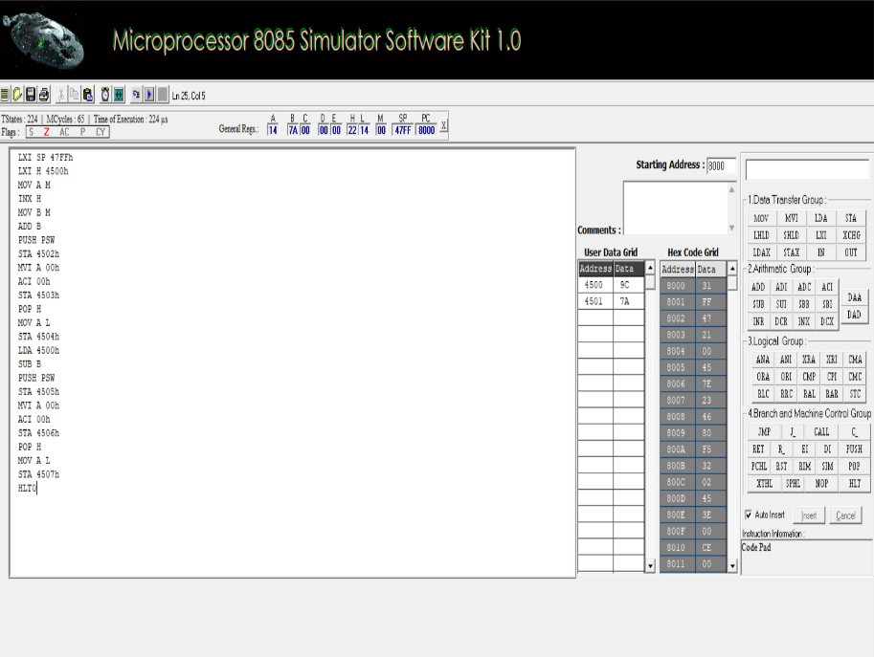

PROGRAM C – 8-bit multiplication and division
Algorithm
- Load the multiplicand and multiplier.
- Initialize the product register pair HL to zero.
- Add the multiplicand repeatedly until the multiplier counter becomes zero.
- Store the 16-bit product.
- Load the dividend and divisor.
- Repeatedly subtract the divisor from the dividend while the dividend is greater than or equal to the divisor.
- Count the subtractions to obtain the quotient.
- Store the quotient and remainder, then halt.
Input memory map
Memory address | Input value | Description
4520h | 12h | Multiplicand
4521h | 05h | Multiplier
4524h | 64h | Dividend
4525h | 05h | Divisor
Output memory map
Memory address | Expected value | Description
4522h | 3Ch | Product lower byte
4523h | 00h | Product upper byte
4526h | 14h | Quotient
4527h | 00h | Remainder
Theory and calculations
Multiplication:
12_h x 05_h=3C_h
In decimal, \(18\times5=90\), which is 5Ah—so the correct hexadecimal product of 12h × 05h is actually 5Ah, not 3Ch.
Division:
64_h / 05_h=14_h
Because 64h is 100 in decimal and 05h is 5, the quotient is 20 decimal (14h) and the remainder is zero.
Expected output
- Product = 005Ah
- Quotient = 14h
- Remainder = 00h
Important correction: The multiplication output in the source's sample values needs verification. The mathematical result for 12h × 05h is 005Ah; use that value when checking the multiplication program.

